**MILESTONE 3 SUBMISSION**

**Group -6** *: Jovita Roshini Arulsamy , Swetha Krishnakumar , Petha Perumal Subramanian*

**1st Normal Form** :

Entity: MEMBERSHIP

Transitive Dependencies Exists : OFFER_ID -> OFFER_DESC, OFFER_VALIDITY

Relational Schema :

Membership(**Membership_ID**,Membership_LName,Membership_FName,Membership_Address,Membership_DOB,Card_ID,Membership_HomeNumber,Membership_Nationality,Offer_ID,Offer_Desc,Offer_Validity,Membership_BetSinceLastClaimed)

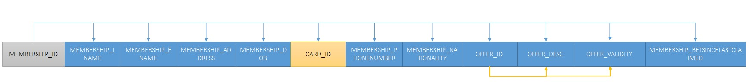

Entity : CARD_GAME

Partial Dependencies Exists : CARD_ID -> CARD_TYPE,CARD_TIER

# GAME_ID -> GAME_TYPE,GAME_NAME

Relational Schema :

Card_Game(**Game_ID,Card_ID**,Game_Type,Game_Name,Card_Type,Card_Tier)

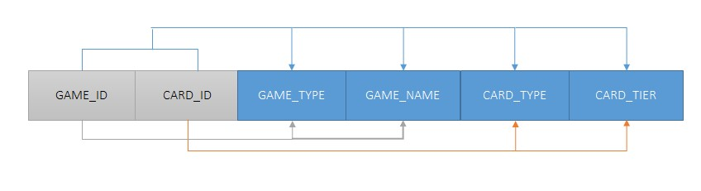

Entity: TRANSACTION

Relational Schema :

Transaction(**Transaction_ID**,Transaction_BetAmnt,Transaction_WinorLossFlag,Transaction_WinorLossAmnt,Game_ID,Membership_ID)

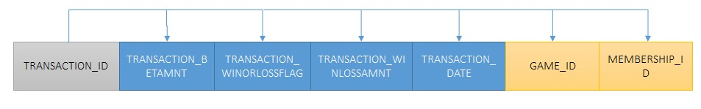

**2nd Normal Form:**

Entity: MEMBERSHIP

Transitive Dependencies Exists : OFFER_ID -> OFFER_DESC, OFFER_VALIDITY

Relational Schema :

Membership(**Membership_ID**,Membership_LName,Membership_FName,Membership_Address,Membership_DOB,Card_ID,Membership_HomeNumber,Membership_Nationality,Offer_ID,Offer_Desc,Offer_Validity,Membership_BetSinceLastClaimed)



Entity : CARD

Relational Schema :

Card(**Card_ID**,Card_Type,Card_Tier)

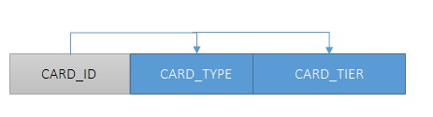

Entity : GAME

Relational Schema :

Game(**Game_ID,**Game_Type,Game_Name)

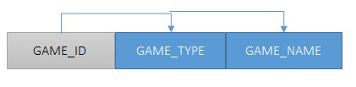

Entity : CARD_GAME

Relational Schema :

Card_Game(**Game_ID,Card_ID**)

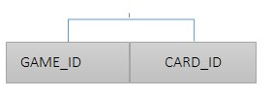

Entity: TRANSACTION

Relational Schema :

Transaction(**Transaction_ID**,Transaction_BetAmnt,Transaction_WinorLossFlag,Transaction_WinorLossAmnt,Game_ID,Membership_ID)

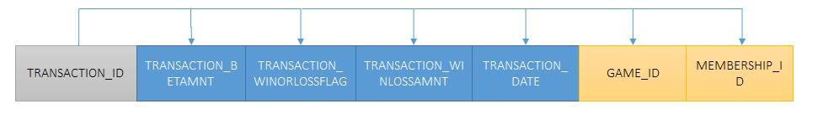

**3rd Normal Form** :

Entity: MEMBERSHIP

Relational Schema :

Membership(**Membership_ID**,Membership_LName,Membership_FName,Membership_Address,Membership_DOB,Card_ID,Membership_HomeNumber,Membership_Nationality,Offer_ID,Membership_BetSinceLastClaimed)

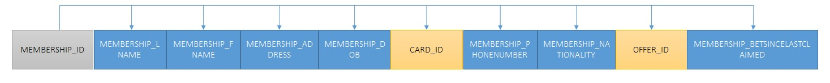

Entity : OFFER

Relational Schema :

Offer(**Offer_ID**,Offer_Desc,Offer_Validity)

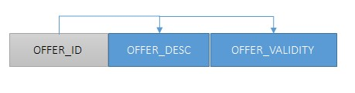

Entity : CARD

Relational Schema :

Card(**Card_ID**,Card_Type,Card_Tier)



Entity : GAME

Relational Schema :

Game(**Game_ID,**Game_Type,Game_Name)



Entity : CARD_GAME

Relational Schema :

Card_Game(**Game_ID,Card_ID**)



Entity: TRANSACTION

Relational Schema :

Transaction(**Transaction_ID**,Transaction_BetAmnt,Transaction_WinorLossFlag,Transaction_WinorLossAmnt,Game_ID,Membership_ID)

